**Oyster Task Force Meeting Minutes**

**Wednesday, March 19, 2025, 10:00am**

**New Orleans Lakefront Airport**

**6001 Stars and Stripes Blvd.**

**New Orleans, LA**

**I.** Pledge of allegiance

**II.** Roll call and introduction of guests

**Voting Members Present:**

Dan Coulon

Brad Robin

Brandt Lafrance

Matthew Slavich

Sam Slavich

Peter Vujnovich

Willie Daisy

**Voting Members Absent:**

Shane Bagala

Brandon Debarge

Jakov Jurisic

Mitch Jurisich

Al Sunseri

Steve Pollock

**Non-Voting Member Present:**

Robert Caballero

Davis Madere

Kyle Balkum

Brian Lezina

**Non-Voting Members Absent:**

Justin Crossie

**III.** Brad Robin motioned to approve the February 18, 2025 meeting minutes, 2nd by Brandt Lafrance. Motion carries.

Brad Robin motioned to approve the March 19, 2025 meeting agenda, 2nd by Brandt Lafrance. Motion carries.

**IV.** Treasury Report

Remaining Fund Balance- $536,194

Remaining Budget Balance- $132,697

February Tag Sales- 190,800

Brad Robin motioned to approve the treasury report as presented, 2nd by Willie Daisy. Motion carries.

**V.** Committee Reports:

A. Public Private Oyster Seed Grounds Committee: NR

B. Enforcement Committee: Davis Madere provided the enforcement report;

February 10th – March 10th

**Region 4** (Iberia)

**Region 5** (Calcasieu and Cameron)

Cameron

**Seizures:**

**Region 6**: (Terrebonne, Lafourche, Grand Isle)

9 – violate sanitation code

1 – unlawfully take oysters from state water bottoms

1 – failure to tag sacked oysters

**Seizures:**

**41 sacks**

**Region 8**: (Jefferson, Plaquemines, St. Bernard, Orleans

**St. Bernard**

1. RS 56: 305 A – Take Commercial Fish W/O Commercial Gear License.
2. RS 40: 4 A – Violate Sanitation Code (Waste Bucket)
3. RS 54: 444- Failure to Display Number on Vessel
4. RS 34: 851.20 F – Expired Boat Registration Certificate

Plaquemines

1 - RS 56: 304 A – Take Commercial Fish Without Vessel License

1 - RS 34: 851.20 F – Expired Boat Registration Certificate

**Seizures:**

11- Sacks seized in connection with these violations and returned to water.

C. Legislative Committee report: The Legislative Committee met prior to the full task force meeting and discussed adding a seat to the LA Oyster Task Force for a representative of the Department of Ag and Forestry

Brad Robin motioned to add a new seat for a non-voting member on the OTF for a representative of the Department of AG and Forestry, 2nd by Sam Slavich. Motion carries.

The committee also discussed amending the oyster harvesters license training; Sam Slavich stated that this requirement has broken the continuity of him harvesting oyster for 5 weeks, also have an issue with the harvester license holding up the other licenses from being in use until the training was completed and the oyster harvesters license is obtained; believe the older fishermen should be grandfathered in and not be required to take this training

The ISSC Model Ordinance has been updated to require some training, will have a meeting this year and a grandfather clause can be brought for consideration at this time

Robert Caballero stated that the harvester training is through a 3rd party website, and there are some issues that LDWF is working out, the renewals issue and the notifications have been solved, working to streamline issues

Willie Daisy stated that the training is done on a computer, need to sit with enforcement, LDWF, and ISSC to implement a grandfather clause, no action needs to be taken at this time, the 2nd issue look at MO and the possibility of grandfathering people in who have had a certain amount of years in the indsutry, there will be an ISSC conference in October can discuss this at the conference

Jen Armentor stated that the training requirement currently states training is a minimum of every 5 years, if you look at the HACCP training there is a caveat that states you have to do the training or who is otherwise qualified under job performance to perform these functions

Brad Robin stated that the third issue that the committee discussed was to consider allowing Calcasieu Lake harvesters to use a mechanical dredge

Brad Robin motioned to support Calcasieu Lake in proposing legislation that would allow the use of dredges in Calcasieu Lake, 2nd by Brandt Lafrance. Motion carries.

D. Legal Committee: No report

E. Research Committee: No report

F. Coastal Restoration Committee: George Ricks provided an update, the Caernarvon and David Pond Diversions both opened up on February 24th; Caernarvon was ran until it was shut down from March 5-8 (coastal flood advisory), Davis Pond is still running at 7200CFS, as we speak CPRA is meeting, in this meeting they will have an executive session to discuss 2 lawsuits pertaining to the Mid-Barataria Sediment Diversion, LT Governor will be in executive session, will find out the results, the 2026 CPRA Annual Plan, boasts a $1.8B plan with 133 active projects, one being the Mid-Barataria Sediment Diversion there is still funding allocated for this, public comment period on the Annual Plan ends Saturday, March 22 which is this weekend for comments on annual plan; the annual plan will start going through the CPRA board in April and through state legislators after that

G. Marketing Committee: No report

H. Health Committee: Jennifer Armentor provided a recap on the recall; 266 confirmed cases, 15 emergency room visits, states involved were FL, AL, MS, NC, and MN, 67 restaurants were involved, 10 seafood markets, 44 dealers involved, for the leases closed for 60 days due to this, scheduled for April 5th opening

Brad Robin stated that some leases that were mentioned in the process who were not supposed to be in the process; the dealer indicated that where oysters were dumped and that lease was implicated in this closure

LDH looked into splitting oyster area three, splitting this area will not require legislation, would like the board’s feedback on this, will put this on the website and allow for industry comment and tweaks

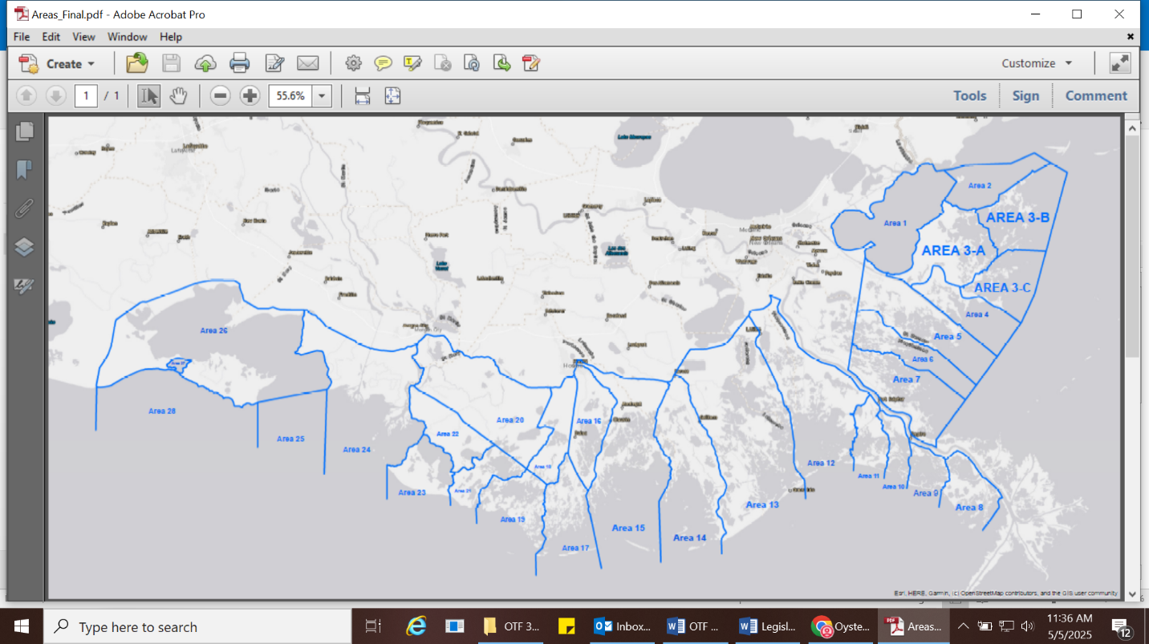

I. Aquaculture Committee: NR

J. Joint Task Force Working Group Committee: NR

**VI.** New Business

1. The task force discussed streamlining the LDWF license process and the possibility of an electronic system

Michael Harden stated that LDWF is working with the group behind LA Wallet to bring commercial and recreational fisher licenses to an electronic system; no gear licenses will be allowed due to issues with enforcement as this license moves with the vessel; if the license/ permit is transferable it will be very difficult to use this system for those licenses

Ante Tesvich stated that the education portion of this will be very important and alerting everyone as to what’s transferable and what’s not. This will need to be clarified even if it is listed on the website so people know what is what, people do not understand how this is going to work, gear licenses are transferable, and seed ground permits are transferrable and are vessel specific

1. Thomas Hymel led discussion on an August 2025 day-long, “LA Oysters in Commerce: Visioning the Future” workshop at LSUAG New Iberia Research Station

Thomas Hymel provided an update on Beyond the Boat and Sea Grant efforts

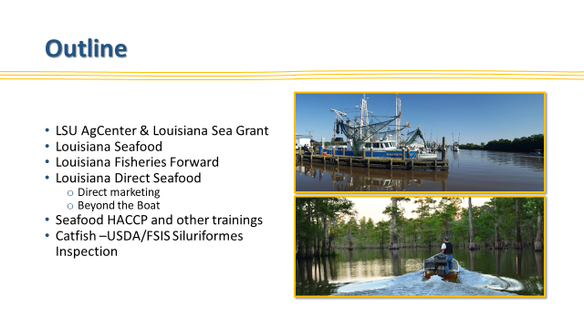

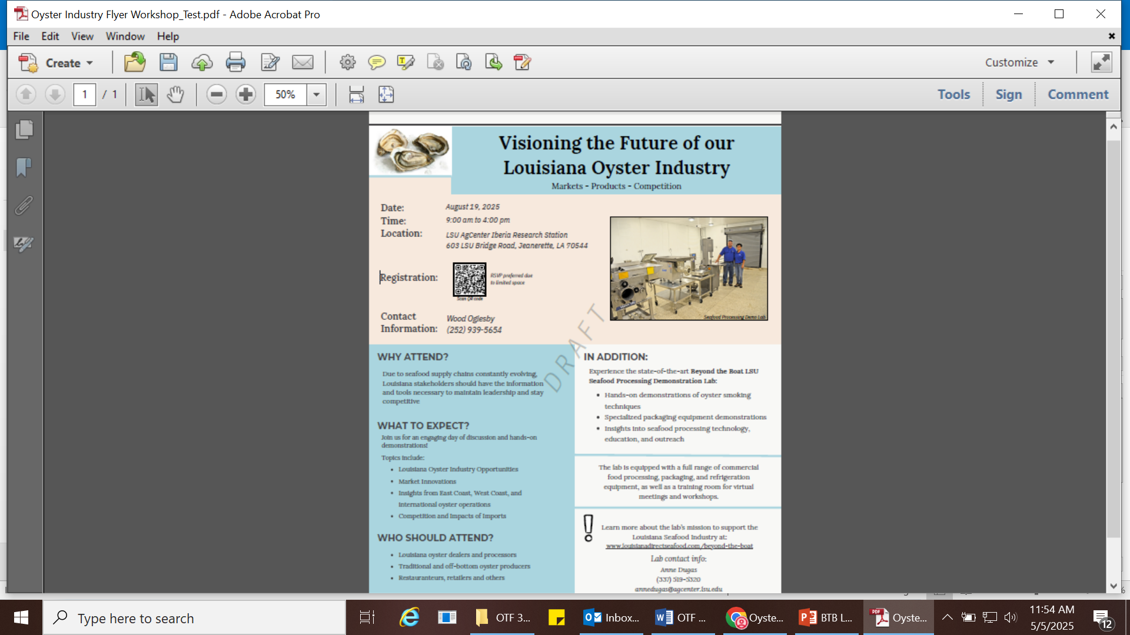

1. The task force considered funding to hire a legislative representative

The board reviewed a proposal from the Chesapeake Group, Eric Sunstrom

Brad Robin motioned to fund up to $20,000 to hire a legislative representative for the Oyster Task Force, 2nd by Sam Slavich. Motion carries.

**VII.** Public Comment:

**VIII.** TBD by chairman at a later date, meeting was later set for Tuesday, May 6, 2025 for 10:00am at the New Orleans Lakefront Airport, the Research Committee plans to meet prior starting their meeting for 9:0am

**IX.** Willie Daisy motioned to adjourn the meeting, 2nd by Brad Robin. Motion carries.